The Talaria TWO device contains one high performance UART which can handle bitrates up to 2.4Mbps. This document describes using the UART with the help of UART APIs provided as part of the SDK.

Current scope of this document is limited to 2-wire UART with software flow control.

Figure 1: Talaria TWO device and HOST device serial communication diagram

The following sample application code and script are included with this application note:

|  |  |
| --- | --- |
| **File** | **Description** |
| uart_tx.c | Sample Talaria TWO application describing the procedure to send data on serial port using UART |
| uart_rx.c | Sample Talaria TWO application describing the procedure to read data on serial port using UART |
| uart_wakeup.c | Sample Talaria TWO application describing sleep/wakeup procedure |
| uart_wakeup.py | Sample HOST side implementation to wake Talaria TWO from sleep |

Table 1: List of files included in the application note

# Basic Usage of UART

This section provides a quick introduction to the UART APIs and describes communication with the host. For a comprehensive description of all the APIs, refer to section 7.

## Opening the Serial Port

Before opening a serial port, a handler must first be allocated.

|  |
| --- |
| struct uart *handle; |

Once the UART handler is available, serial port can be opened using two different functions:

1. uart_open – Opens serial port using default PINs and configured baud rate.

|  |
| --- |
| handle = uart_open(baudrate); |

1. uart_open_ex – Opens the serial port using the configured baud rate, TXD, and RXD PINs.

|  |
| --- |
| #define TXD_PIN 1  #define RXD_PIN 2  …  int baudrate = 115200;  handle = uart_open_ex(baudrate, TXD_PIN, RXD_PIN, 0); |

Here, we configure the UART at a baud rate of 115200, GPIO1 as the TXD pin, and GPIO2 as the RXD pin.

## Closing the Serial Port

uart_close is used to close the serial port.

|  |
| --- |
| uart_close(handle); |

## Transmitting a Single Character

uart_putchar is used to transmit a single character.

|  |
| --- |
| char c = ‘z’;  …  uart_putchar(handle, c); |

## Transmitting a String

uart_puts is used to transmit a string.

|  |
| --- |
| const char *message = ”Hello”;  …  uart_puts(handle, message); |

## Receiving (Blocking)

uart_getchar is used to read a character from the serial port. This function call blocks until a byte is read.

|  |
| --- |
| int c = uart_getchar(handle); |

## Receiving (Blocking with Timeout)

uart_getchar_tmo is used to read a character from the serial port with a timeout. This function call blocks until a byte is read or it times out.

|  |
| --- |
| int c = uart_getchar_tmo(h, 1000000); //1s sec timeout  if (c == -1) //uart_getchar_tmo returns -1 on timeout  break;  else  os_printf("%d_", c); |

## Register Event Callback (called when Talaria TWO wakes from sleep)

|  |
| --- |
| static void __irq  handle_event(struct uart *u, enum uart_event type, void *priv)  {  //do stuff here  }  …  int main()  {  …  uart_set_event_callback(handle, handle_event, NULL);  } |

## Register Callback (called when special character is received)

|  |
| --- |
| const char special = ‘z’;  …  static void uart_cb(void)  {  //do stuff here  }  …  int main()  {  uart_set_callback(handle, uart_cb, special);  } |

# Recommended Protocol for 2-wire UART

Since 2-wire UART has no hardware flow control, a software protocol is recommended in this section.

## Power-ON

1. After powering ON Talaria TWO, UART initialization is completed with required baud rate.
2. Talaria TWO then sends a known byte pattern to the host indicating the readiness for UART transactions as illustrated in Figure 2.

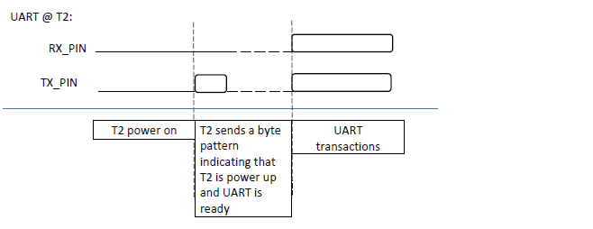

Figure 2: Recommended Talaria TWO protocol for power-ON case

# UART APIs

1. uart_open – Opens UART port.
2. uart_close – Closes UART port.
3. uart_getchar - Reads the next character from UART. If no character is available, the function will block the calling thread until a character arrives in UART.
4. uart_getchar_tmo – Reads the next character from the UART. If no character is available, the function will block the calling thread until either timeout occurs or a character arrives in UART.
5. uart_putchar – Write one character to UART.
6. uart_puts - Write a string to UART.
7. uart_flush – Flushes the output buffer.
8. uart_open_ex – Opens UART port with extended parameters.
9. uart_set_event_callback – Enables callback on events described by the enum uart_event.
10. uart_set_callback – Enables callback, when a certain character is entering the UART. This callback is executed in interrupt context.
11. uart_suspend_enable – Enables sleep mode.
12. os_gpio_request – Allocates and sets up PINs as GPIO.
13. os_gpio_set_output – Sets up GPIO PINs for output.
14. os_gpio_set_pin – Sets the specified GPIO PINs.
15. os_gpio_clr_pin – Clears the specified GPIO PINs.
16. uart_getchar_tmo – Reads one character from the serial port, with timeout.
17. uart_putchar – Writes one character to the serial port.

## UART-RX

### Code Walkthrough

uart_rx.c is used to read data on serial port using UART. This receives the character sent from the host device to Talaria TWO through the UART. Data will be printed on the console which can be used to verify the working of the application.

struct uart is an opaque object representing the UART. This function will initialize and allocate buffer space for the UART functions.

|  |
| --- |
| struct uart *handle; |

The function will return a pointer to an opaque object which is used as a handle in subsequent calls to the UART functions. It opens the serial port using baud rate 921600.

|  |
| --- |
| handle = uart_open(921600);  if (handle == NULL)  return 1; |

uart_puts() function writes the null terminated string pointed to by str to the serial port. The terminating null byte ('\0') will not be written.

|  |
| --- |
| int c = uart_getchar_tmo(handle, 1000000); |

uart_getchar_tmo() function reads the next character from the serial port. If no character is available, the function will block the calling thread with timeout. Here, the timeout is 1 second.

|  |
| --- |
| if(c !=-1)  os_printf("%c", c); |

uart_close() function closes the serial port and releases the memory claimed by the uart_open() call. Any characters left in the output buffers will be discarded.

|  |
| --- |
| uart_close(handle); |

### Running the Application

**Note**: All applicable ELFs are available in the FreeRTOS SDK package at: *freertos_sdk_x.y\examples\lp_uart\bin*.

x and y refer to the SDK release version. For example: *freertos_sdk_2.5\doc*.

Program uart_rx.elf () using the Download tool:

1. Launch the Download tool provided with InnoPhase Talaria TWO SDK.
2. In the GUI window:
   1. Boot Target: Select the appropriate EVK from the drop-down
   2. ELF Input: Load the uart_rx.elf by clicking on Select ELF File.
   3. Programming: Prog RAM or Prog Flash as per requirement.

For more details on using the Download tool, refer to the document: UG_Download_Tool.pdf (path: *freertos_sdk_x.y\pc_tools\Download_Tool\doc*).

### Expected Output

uart_rx console output:

|  |
| --- |
| Y-BOOT 208ef13 2019-07-22 12:26:54 -0500 790da1-b-7  ROM yoda-h0-rom-16-0-gd5a8e586  FLASH:PNWWWAE  Build $Id: git-6e0f116 $  Flash detected. flash.hw.uuid: 39483937-3207-0083-00a1-ffffffffffff  $App:git-e8cee79  SDK Ver: FREERTOS_SDK_1.0  Lpuart Rx Demo App  Starting uart_rx_thread |

Open a minicom terminal with a baud rate of 921600, with no hardware flow control and add the serial device.

Once the minicom starts, reset Talaria TWO which displays the output string.

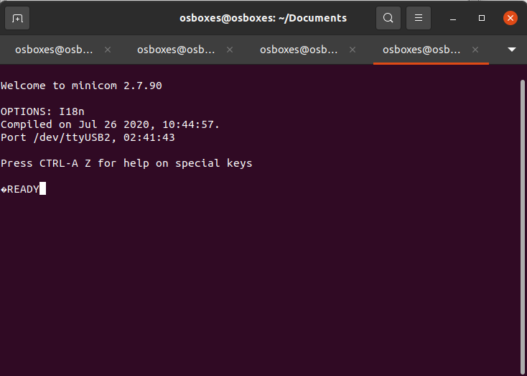

Figure 3: UART - RX Minicom Output

## UART-TX

### Code Walkthrough

The uart_tx.c is used to send data on serial port using UART. This transmits a string of data "Hello world" from Talaria TWO to host through the UART.

The struct uart opaque object represents the UART. This function will initialize and allocate buffer space for the UART functions.

|  |
| --- |
| struct uart *handle; |

The function will return a pointer to an opaque object that is used as a handle in subsequent calls to the UART functions. It opens the serial port using baud rate 921600.

|  |
| --- |
| handle = uart_open(921600);  if (handle == NULL)  return 1; |

This function will write the null terminated string pointed to by str to the serial port. The terminating null byte ('\0') will not be written.

|  |
| --- |
| uart_puts(handle, "Hello World\n"); |

uart_flush()calls the thread until all characters currently buffered for output have been written to the serial port.

|  |
| --- |
| uart_flush(handle); |

The uart_close() function closes the serial port and releases the memory claimed by the uart_open() call.

|  |
| --- |
| uart_close(handle); |

### Running the Application

Program uart_tx.elf using the Download tool:

1. Launch the Download tool provided with InnoPhase Talaria TWO SDK.
2. In the GUI window:
   1. Boot Target: Select the appropriate EVK from the drop-down
   2. ELF Input: Load the uart_tx.elf by clicking on Select ELF File.
   3. Programming: Prog RAM or Prog Flash as per requirement.

### Expected Output

uart_tx console output:

|  |
| --- |
| Y-BOOT 208ef13 2019-07-22 12:26:54 -0500 790da1-b-7  ROM yoda-h0-rom-16-0-gd5a8e586  FLASH:PNWWWAE  Build $Id: git-6e0f116 $  Flash detected. flash.hw.uuid: 39483937-3207-0083-00a1-ffffffffffff  $App:git-e8cee79  SDK Ver: FREERTOS_SDK_1.0  Lpuart Tx Demo App |

Open a minicom terminal with a baud rate of 921600, with no Hardware flow control and add the serial device.

Once the minicom starts, reset the Talaria TWO device which displays the output string.

Figure 4: UART – TX Minicom Output

## UART Suspend/Wakeup

### Code Walkthrough

uart_wakeup.c

The sample application uart_wakeup.c shows a basic implementation of UART suspend/wakeup using UART_BREAK signal.

This section describes the state of the UART, whether the link is up or down.

|  |
| --- |
| enum uart_link_state {  UART_LINK_UP = 0,  UART_LINK_DOWN,  } link |

handle_event() handles the UART events and checks if the type is UART_EVENT_WAKEUP. If yes, then the uart_status will be set to UART_WAKE until suspend state is enabled.

|  |
| --- |
| static void __irq  handle_event(struct uart *h, enum uart_event type, void *priv)  {  if (type == UART_EVENT_WAKEUP)  {  pr_always("UART_EVENT_WAKEUP\n");  uart_status=UART_WAKE;  struct uart_wakeup_msg *msg  = (struct uart_wakeup_msg *)osal_alloc(sizeof(*msg));  msg->event = APP_MSG_AWAKE_UART;  xQueueSendFromISR(uart_event_queue, (void *)&msg, NULL);  }  } |

os_gpio_request() API requests the pins and configures the pin as GPIO, os_gpio_set_output() API configures the GPIO pins as digital output pins, os_gpio_clr_pin() is used to clear the specified GPIO pins, os_gpio_set_pin() is used to set the GPIO high and os_gpio_clr_pin() is used to set GPIO low.

|  |
| --- |
| void app_main(void *arg)  {  uint32_t ulValue, recv_status;  struct uart_wakeup_msg *msg = NULL;  os_gpio_request(sig_pin);  os_gpio_set_output(sig_pin);  uart_suspend_enable(u);  while (1) {  os_gpio_set_pin(sig_pin);  /* blocking. */  recv_status  = xQueueReceive(uart_event_queue, &ulValue, portMAX_DELAY);  os_gpio_clr_pin(sig_pin);  if (0 == recv_status)  continue;  msg = (struct uart_wakeup_msg *)ulValue;  if (msg->event == APP_MSG_AWAKE_UART) {  {  if(uart_status != UART_INACTIVE)  {  int c = uart_getchar_tmo(u, UART_TMO_CLR); // read and drop garbage byte  rx_ready = true;  uart_putchar(u, 'R'); // can be used for syncing    while(rx_ready)  {  c = uart_getchar_tmo(u, UART_TMO_FIRST_BYTE); //first byte may take a while depending on when the event gets triggered  while(c!=-1)  {  /**  * We look for '*' to signify end of message.  * Ideally the HOST and T2 would use an agreed upon protocol to determine length and validity of packet from HOST  **/  if((char)c == '*')  {  uart_putchar(u, 'A');    }  c = uart_getchar_tmo(u, UART_TMO_BYTE);  }  // process message here    // wait and check if HOST plans to send more packets  c = uart_getchar_tmo(u, UART_TMO_EXTENDED); //should catch the break  if(c == -1)  {  //no additional packet/s  rx_ready = false;  }  }  uart_putchar(u, 'S');  pr_always("uart_suspend_enable\n");  uart_suspend_enable(u);  uart_status=UART_INACTIVE;  }  }  osal_free(msg);  }  } |

wcm_create()API from the Wi-Fi Connection Manager is used to connect to a Wi-Fi network. Initially, the Wi-Fi network interface is created using wcm_create().

wifi_connect_to_network()API, from components library, connects to the Wi-Fi network using the AP credentials provided.

|  |
| --- |
| /*Create a Wi-Fi network interface*/  wcm_handle = wcm_create(NULL);  /* Read the configuration and connect to desired network */  rval = wifi_connect_to_network(&wcm_handle, WCM_CONN_WAIT_INFINITE, &wcm_connected);  if(rval < 0) {  os_printf("\nError: Unable to connect to network\n");  return 0;  }  if(wcm_connected != true) {  os_printf("\nCouldn't Connect to network ");  wcm_disconnect(wcm_handle);  } |

uart_wakeup_host.c

The sample application uart_wakeup_host.c shows implementation of a HOST MCU which can wakeup Talaria TWO using UART.

A serial port with a baud rate of 115200 is opened using uart_open().

**Single Packet Test**:

Single packet test prints the errors along with the 1000 packets.

Pins and GPIOs are used to emulate a long UART_BREAK signal. Here uart_getchar_tmo() reads one character “R” from the serial port which indicates Ready. If no character is available, the function will block the calling thread until timeout occurs.

Host will again wait for Talaria TWO to echo back the last end sync character which is the acknowledgement “A” packet.

|  |
| --- |
| u = uart_open(115200);  int count = 0;  int errors = 0;  int packets = 1000;  char count_buffer[32];  bool retransmit = false;  os_printf("Single packet test\n");  while(count < packets)  {  //Use pin ad GPIO to emulate a long UART_BREAK signal  int tx_pin = 1 << TX_PIN;  os_gpio_set_mode(tx_pin, GPIO_MODE);  os_gpio_request(tx_pin);  os_gpio_set_output(tx_pin);  os_gpio_clr_pin(tx_pin);  vTaskDelay(1);  os_gpio_set_pin(tx_pin);  os_gpio_set_input(tx_pin);  os_gpio_set_mode(tx_pin, GPIO_FUNCTION_MODE);  os_gpio_free(tx_pin);  while(1)  {  //Wait for ready 'r' from T2  int sync = uart_getchar_tmo(u, 1000);  if(sync == -1)  {  break;  }  else if((char)sync == 'R')  {  if(retransmit)  {  errors++;  os_printf("retransmitting!!!\n");  }  memset(count_buffer, 0, 32);  sprintf(count_buffer, "count: %d\n", count);  uart_write((void*)msg1, strlen(msg1));  uart_write((void*)msg2, strlen(msg2));  uart_write((void*)count_buffer, strlen(count_buffer));  uart_write((void*)msg4, strlen(msg4)); //send end sync char '*'  uart_flush(u);  //Wait for T2 to echo back the last end sync char '*'  sync = uart_getchar_tmo(u, 2000);  retransmit = true;  while(sync != -1)  {  if(sync == 'A')  {  retransmit = false;  count++;  break;  }  sync = uart_getchar_tmo(u, 2000);  }  break;  }  }  if(!retransmit)  {  vTaskDelay(50);  }  }  os_printf("%d errors to send %d packets\n", errors, packets); |

**Multiple Packet Test**:

Multiple packet test prints the errors along with the 1000 packets.

PINs and GPIOs are used to emulate a long UART_BREAK signal. Here uart_getchar_tmo() reads one character “R” from the serial port which indicates Ready. If no character is available, the function will block the calling thread until timeout occurs.

Host will again wait for Talaria TWO to echo back the last end sync character which is the acknowledgement “A” packet.

|  |
| --- |
| count = 0;  os_printf("Multi packet test\n");  while(count < packets)  {  //Use pin ad GPIO to emulate a long UART_BREAK signal  int tx_pin = 1 << TX_PIN;  os_gpio_set_mode(tx_pin, GPIO_MODE);  os_gpio_request(tx_pin);  os_gpio_set_output(tx_pin);  os_gpio_clr_pin(tx_pin);  vTaskDelay(1);  os_gpio_set_pin(tx_pin);  os_gpio_set_input(tx_pin);  os_gpio_set_mode(tx_pin, GPIO_FUNCTION_MODE);  os_gpio_free(tx_pin);    while(1)  {  //Wait for ready 'r' from T2  int sync = uart_getchar_tmo(u, 1000);  if(sync == -1)  {  break;  }  else if((char)sync == 'R')  {  if(retransmit)  {  errors++;  os_printf("retransmitting!!!\n");  }  memset(count_buffer, 0, 32);  sprintf(count_buffer, "count: %d\n", count);  uart_write((void*)msg1, strlen(msg1));  uart_write((void*)msg2, strlen(msg2));  uart_write((void*)count_buffer, strlen(count_buffer));  uart_write((void*)msg4, strlen(msg4)); //send end sync char '*'  uart_flush(u);  //Wait for T2 to echo back the last end sync char '*'  sync = uart_getchar_tmo(u, 2000);  retransmit = true;  while(sync != -1)  {  if(sync == 'A')  {  retransmit = false;  count++;  break;  }  sync = uart_getchar_tmo(u, 2000); } |

Using PINs and GPIOs emulate a long UART_BREAK signal and send the second packet before Talaria TWO UART goes into suspend state. uart_flush() and uart_close() are used to empty the output buffers before closing.

|  |
| --- |
| vTaskDelay(5);  // send second packet before T2 UART goes into suspend  //Use pin ad GPIO to emulate a long UART_BREAK signal  tx_pin = 1 << TX_PIN;  os_gpio_set_mode(tx_pin, GPIO_MODE);  os_gpio_request(tx_pin);  os_gpio_set_output(tx_pin);  os_gpio_clr_pin(tx_pin);  vTaskDelay(1);  os_gpio_set_pin(tx_pin);  os_gpio_set_input(tx_pin);  os_gpio_set_mode(tx_pin, GPIO_FUNCTION_MODE);  os_gpio_free(tx_pin);    memset(count_buffer, 0, 32);  sprintf(count_buffer, "count: %d\n", count);  uart_write((void*)msg1, strlen(msg1));  uart_write((void*)msg2, strlen(msg2));  uart_write((void*)count_buffer, strlen(count_buffer));  uart_write((void*)msg4, strlen(msg4)); //send end sync char '*'  uart_flush(u);  //Wait for T2 to echo back the last end sync char '*'  sync = uart_getchar_tmo(u, 2000);  retransmit = true;  while(sync != -1)  {  if(sync == 'A')  {  retransmit = false;  count++;  break;  }  sync = uart_getchar_tmo(u, 2000);  }  break;  }  }  if(!retransmit)  {  vTaskDelay(50);  }  }  os_printf("%d errors to send %d packets\n", errors, packets);  /* Make sure the output buffers are empty before closing. */  uart_flush(u);  uart_close(u);  return 0;  } |

### Hardware Connection

Using two Talaria TWO boards and a logic analyzer make the connection using the required wires and breadboard as shown in Figure 5.

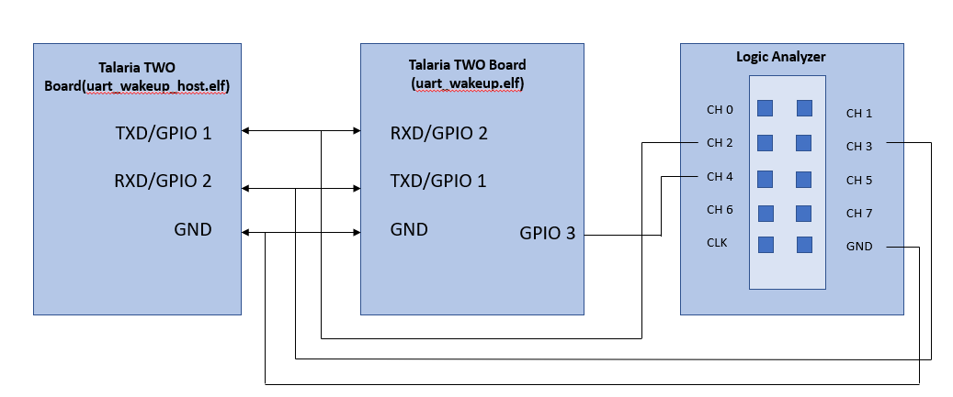

Figure 5: UART suspend/wakeup - hardware connection

### Running the Application

Program uart_wakeup_host.elf and uart_wakeup.elf onto Talaria TWO boards using the Download tool:

1. Launch the Download Tool provided with InnoPhase Talaria TWO SDK.
2. In the GUI window:
   1. Boot Target: Select the appropriate EVK from the drop-down
   2. ELF Input: Load uart_wakeup_host.elf and uart_wakeup.elf by clicking on Select ELF File.
   3. AP Options: Pass the appropriate SSID and passphrase to connect to an Access Point for uart_wakeup.elf.
   4. Programming: Prog RAM or Prog Flash as per requirement.

### Expected Output

Once the hardware connection is complete as described in section 7.3.2, flash Talaria TWO boards with uart_wakeup_host.elf and uart_wakeup.elf . Simultaneously reset on Talaria TWO’s GUI or press the hard reset button on Talaria TWO boards and observe the following console outputs:

uart_wakeup.elf:

|  |
| --- |
| Y-BOOT 208ef13 2019-07-22 12:26:54 -0500 790da1-b-7  ROM yoda-h0-rom-16-0-gd5a8e586  FLASH:PNWWWWWWWAE  Build $Id: git-6e0f116 $  Flash detected. flash.hw.uuid: 39483937-3207-0083-00a1-ffffffffffff  Bootargs: np_conf_path=/data/nprofile.json ssid=tplinkc6_iop passphrase=InnoQA2023$  Sleep wakeup Test  $App:git-894dc59  SDK Ver: FREERTOS_SDK_1.0  UART Wakeup  addr e0:69:3a:00:15:b0  Connecting to added network : tplinkc6_iop  [0.868,199] CONNECT:10:27:f5:7d:e8:74 Channel:9 rssi:-27 dBm  wcm_notify_cb to App Layer - WCM_NOTIFY_MSG_LINK_UP  [1.071,828] MYIP 192.168.0.146  [1.071,877] IPv6 [fe80::e269:3aff:fe00:15b0]-link  wcm_notify_cb to App Layer - WCM_NOTIFY_MSG_CONNECTED  wcm_notify_cb to App Layer - WCM_NOTIFY_MSG_ADDRESS  Connected to added network : tplinkc6_iop  os_suspend_enable  os_suspend_enable  [46.813,497] UART_EVENT_WAKEUP  [46.825,104] uart_suspend_enable  [46.825,282] UART_EVENT_WAKEUP  [46.837,110] uart_suspend_enable  [46.837,287] UART_EVENT_WAKEUP  [46.849,113] uart_suspend_enable  [46.849,292] UART_EVENT_WAKEUP  [46.861,120] uart_suspend_enable  [46.861,297] UART_EVENT_WAKEUP  [46.873,123] uart_suspend_enable  [46.873,303] UART_EVENT_WAKEUP  [46.885,127] uart_suspend_enable  [46.885,308] UART_EVENT_WAKEUP  [46.897,131] uart_suspend_enable  [46.897,313] UART_EVENT_WAKEUP  [46.909,135] uart_suspend_enable  [46.909,318] UART_EVENT_WAKEUP  [46.921,139] uart_suspend_enable  [46.921,323] UART_EVENT_WAKEUP  [46.933,145] uart_suspend_enable  [46.933,328] UART_EVENT_WAKEUP  [46.945,148] uart_suspend_enable  [46.945,334] UART_EVENT_WAKEUP  [46.957,161] uart_suspend_enable  [46.957,339] UART_EVENT_WAKEUP  [46.969,164] uart_suspend_enable  [46.969,344] UART_EVENT_WAKEUP  [46.981,168] uart_suspend_enable  [46.981,349] UART_EVENT_WAKEUP  [46.993,172] uart_suspend_enable  [46.993,354] UART_EVENT_WAKEUP  [47.005,176] uart_suspend_enable  [47.005,359] UART_EVENT_WAKEUP  [47.017,182] uart_suspend_enable  [47.017,365] UART_EVENT_WAKEUP  [47.029,185] uart_suspend_enable  [47.029,370] UART_EVENT_WAKEUP  [47.041,189] uart_suspend_enable |

uart_wakeup_host.elf:

|  |
| --- |
| Y-BOOT 208ef13 2019-07-22 12:26:54 -0500 790da1-b-7  ROM yoda-h0-rom-16-0-gd5a8e586  FLASH:PNWWWWAE  Build $Id: git-6e0f116 $  Flash detected. flash.hw.uuid: 39483937-3207-0083-00a1-ffffffffffff  Single packet test  0 errors to send 1000 packets  Multi packet test  0 errors to send 1000 packets |

Following output is observed on the logic analyzer:

The UART interface on Talaria TWO can be placed in suspend mode while there is no UART activity between Talaria TWO and Host.   
To wake up Talaria TWO from sleep and re-enable the UART interface, the Host needs to send the UART_BREAK signal for a minimum duration of 1ms.

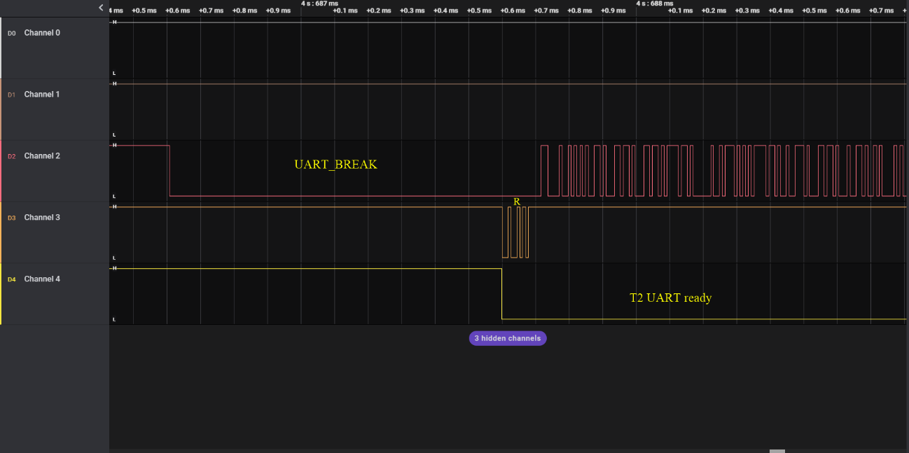

Figure 6: UART suspend/wakeup - Wakeup from UART_BREAK

uart_wakeup example follows the subsequent protocol:

1. HOST sends break.
2. Talaria TWO wakes up and takes UART out of SUSPEND. Talaria TWO sends a byte ‘R’ to inform the Host that UART interface is ready.
3. Host (optionally) waits for ~1ms or ‘R’ and then sends data.
4. Talaria TWO receives the data.

Note: Talaria TWO performs error checking and lets the Host know if re-transmit is required.

* 1. Talaria TWO can determine whether the Host is done sending either by a timeout or similar protocol.
  2. Talaria TWO sends an acknowledgement byte ‘A’ after validating the packet.
  3. Talaria TWO optionally waits (~10 ms) for more incoming packets.

1. Talaria TWO sends a byte ‘S’ to the Host to inform the Host that the UART is entering SUSPEND state.

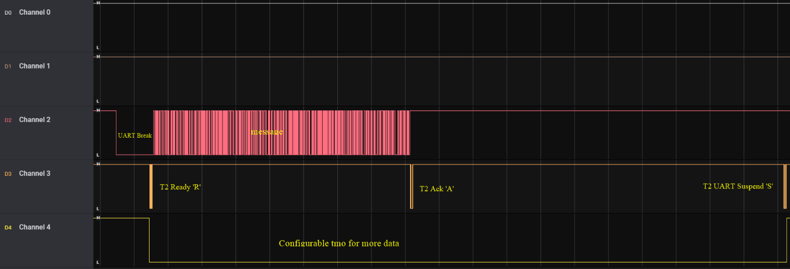

Figure 7: Wakeup from UART_BREAK and IPC communication with HOST